DESIGN TABLES FOR PRODUCT AND CATEGORY ENTITIES.
Project Title: E-Commerce Order Management Database System

Project Title : E-Commerce Order Management Database System
Student Name : PRIYA M
Register Number : C4S38003
Department: Bsc
Course : Artificial intelligence (AI)
Academic Year : 2026 – 2027

Step 1: Create Database
CREATE DATABASE EcommerceDB;
USE EcommerceDB;

Step 2: Create Category Table
CREATE TABLE Category (
CategoryID INT PRIMARY KEY,
CategoryName VARCHAR(50) NOT NULL
);

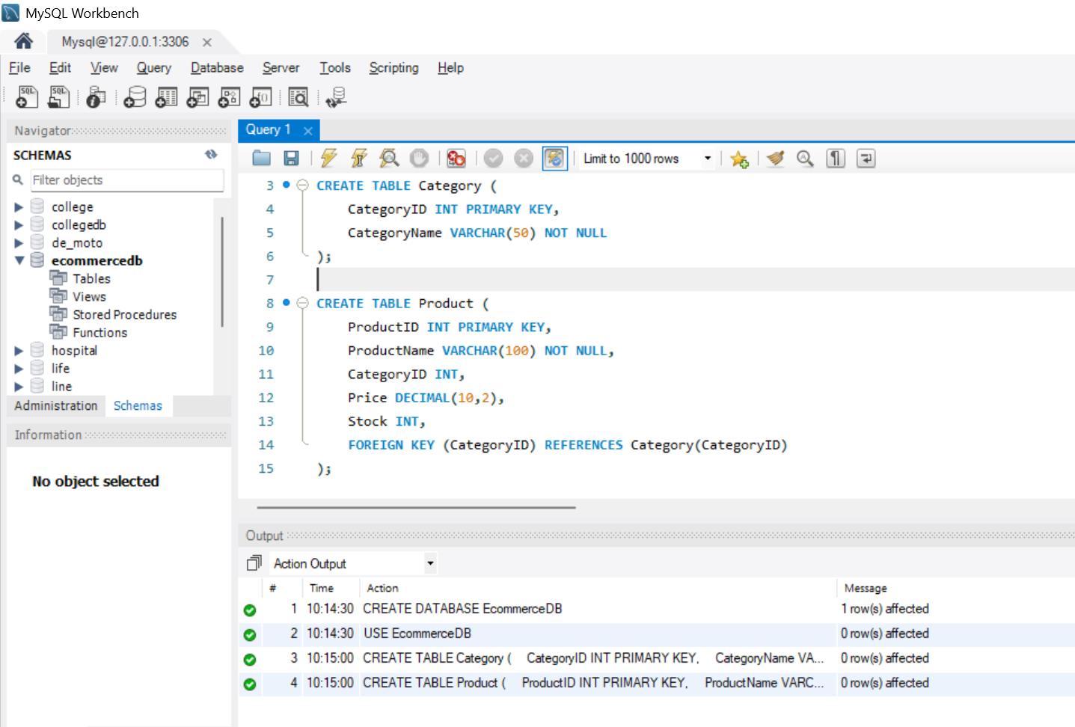

Step 3: Create Product Table
CREATE TABLE Product (
ProductID INT PRIMARY KEY,
ProductName VARCHAR(100) NOT NULL,
CategoryID INT,
Price DECIMAL(10,2),
Stock INT,
FOREIGN KEY (CategoryID) REFERENCES Category(CategoryID)
);

Primary Key
- CategoryID → Primary Key in Category
- ProductID → Primary Key in Product

Foreign Key
- CategoryID in Product references Category(CategoryID).

Step 4: Insert Data

Insert Categories
INSERT INTO Category VALUES
(1, 'Electronics'),
(2, 'Clothing'),
(3, 'Books');

Insert Products
INSERT INTO Product VALUES
(101, 'Laptop', 1, 55000, 15),
(102, 'Mobile', 1, 25000, 30),
(103, 'T-Shirt', 2, 800, 50),
(104, 'Novel', 3, 450, 20);

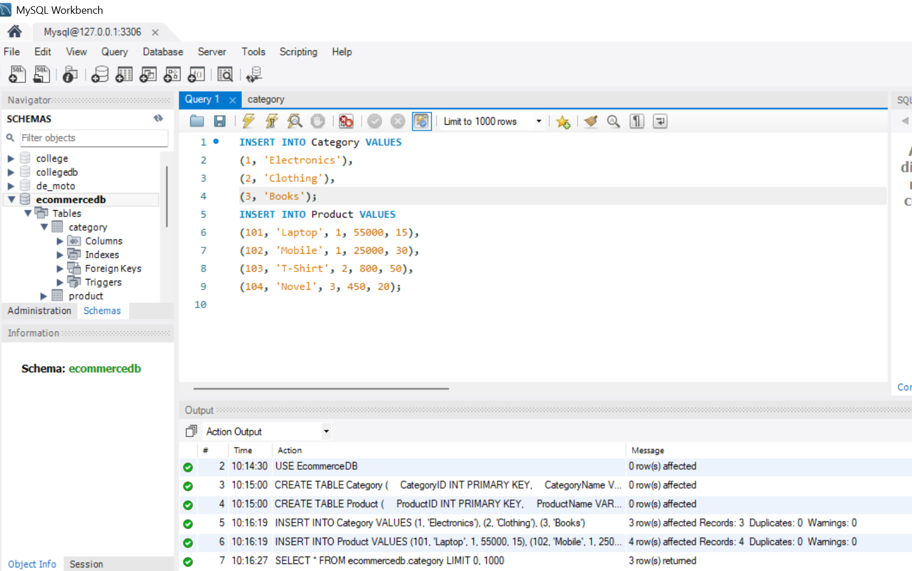

Step 5: Display Data
SELECT * FROM Category;

SELECT * FROM Product;

Step 6: Update Product
Example: Change Laptop price and stock.
UPDATE Product
SET Price = 53000,
Stock = 18
WHERE ProductID = 101;

Step 7: Delete Product
Delete the Novel product.
DELETE FROM Product
WHERE ProductID = 104;

Step 8: Category-wise Product Report
SELECT
c.CategoryName,
p.ProductName,
p.Price,
p.Stock
FROM Category c
JOIN Product p
ON c.CategoryID = p.CategoryID;

